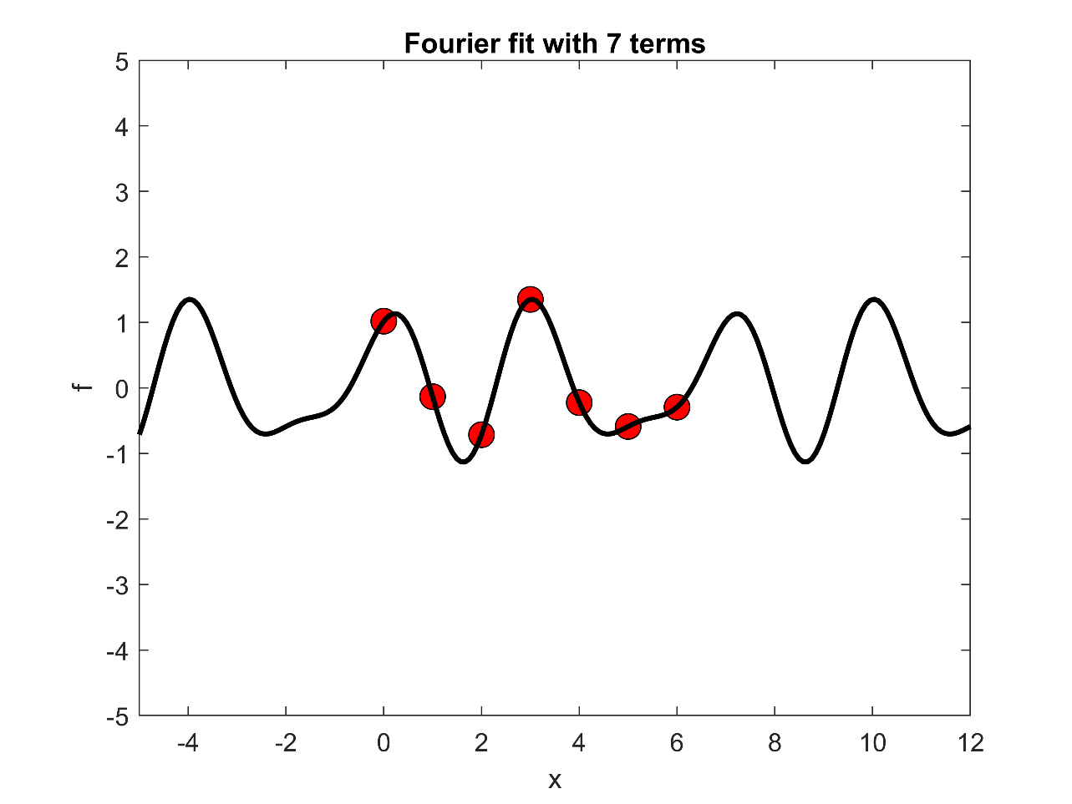

Figure 1: A fourier fit using seven terms of the Fourier Series, up to n = 3. k = 2π/7. The seven initial points (red dots) are randomly selected, and from which a fourier fit (in black) is generated.

A fourier fit using seven terms of the Fourier Series is generated using seven initial points. The coefficients are found from solving a system of seven linear equations using the backslash operator. The seven linear equations are generated from the seven initial points and are represented in matrix form in order to use the backslash operator.